Ysgol Gymuned Lôn Barcas
Lôn Barcas
Wrecsam
LL13 9TP
Ffôn 01978 357754

Barker’s Lane Community School
Barker’s Lane
Wrexham
LL13 9TP
Tel 01978 357754

Ysgol Gymuned Lôn Barcas
Barker’s Lane Community School

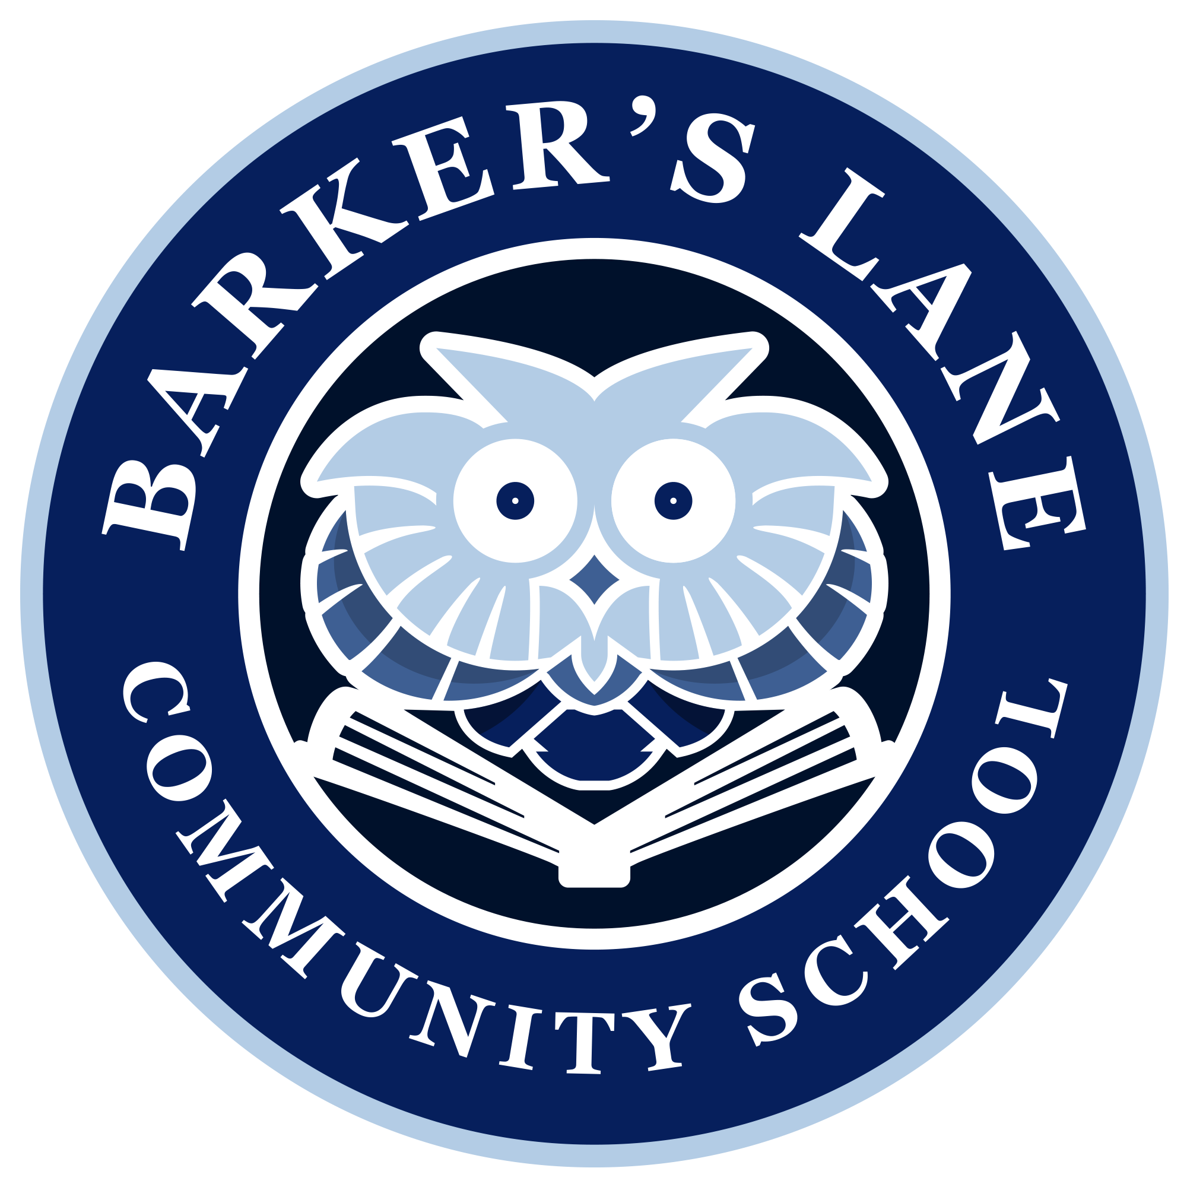

LEARN TOGETHER
‘Let’s learn to enjoy, achieve, respect and nurture together’

12th April 2018

Dear Parent / Carer

A warm welcome back as we now approach the end the first week after the Easter break. Dates for this term, including information about extra-curricular clubs were sent out earlier in the week, are on the school app and the calendar on the school website. I would also like to share the following information with you:

Homework
This term we will be trialling a new approach to homework for Y1 – Y6 children by providing a menu of activities for the term which have been developed with the children in each class. It will be up to each individual child together with you as parents to choose which tasks will be completed. There are a variety of tasks, including literacy, numeracy, topic, art, etc. Most of the tasks can be related to the class topic, real life activities or your child’s own interests.
We will be setting aside time every week or any children who wish to bring in what they have done so far to share with the class. We will be asking all children to complete a minimum of three tasks of their choice by half term and a further three by the end of the Summer Term. Children are very welcome to complete as many of the tasks as they so wish beyond the minimum that we expect.
Our aim is to build on a love of learning and provide more flexibility for shared learning at home.

If after the explanation leaflet and tasks are sent home next week you require any further clarification, please don’t hesitate to speak to your child’s teacher. There has been a very positive response from the children in each class and we look forward to hearing feedback from yourselves later this term.

Further information will be sent home on with tasks next Friday. There will be no formal homework other than usual reading and online maths this Friday.

We strongly encourage reading / sharing books each day for all children. Online maths will also continue to be allocated each Friday for practising skills taught in class.

Internet Safety Presentation for Parents – Thursday 19th April 6pm
You may remember that before the holiday we shared that the internet safety presentation which was postponed due to the snow would take place on Thursday 19th April at 6pm.
An increasing number of issues are brought to our attention ranging from inappropriate gaming, cyberbullying, sharing inappropriate videos / images and the use of offensive language / terms online. I would encourage as many parents as possible to attend this session with a member of the police force with the most up to date information for protecting children and ourselves as adults online. The session will last no longer that one hour. Please return the proforma below to indicate whether you are able / unable to attend by Tuesday 17th April.

Yours faithfully

C A Edwards
Headteacher / Pennaeth

…………………………………………………………………………………………………………………..
Internet Safety Presentation – Thursday 19th April 6pm

Parent/s of: ………………………………………..(child’s name) Class:………………………..

I / We will be attending the session. I / We require ……… chairs. (Please indicate no of seats required)

I / We will not be attending the above session.

