Parenting Support Service

OPen day for families @ Ty Ni Family Centre
82 Rhosddu Road Wrexham
Family Aid
Challenging Years
Specialized Parenting

Parent Network Informal Drop in groups
Domestic Abuse/Freedom Programme/ Gateway
Flying Start
Willow
Substance Misuse Team
Family Links
Strengthening Families

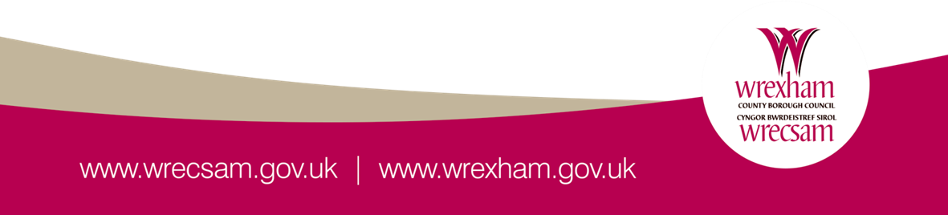
Thursday 24th January 4.30 – 7pm
Have you ever wondered what Family Centre can offer you and your family? Why not pay us a visit on our open day. It is a great opportunity for families to meet the staff, and find out what we offer to support parents/carers and children. Find out information on the parenting courses and support services that are available to you, and how else we can support your family.
SMALL BUFFET AVAILABLE

