Ysgol Gymuned Lôn Barcas
Lôn Barcas
Wrecsam
LL13 9TP
Ffôn 01978 357754

Barker’s Lane Community School
Barker’s Lane
Wrexham
LL13 9TP
Tel 01978 357754

Ysgol Gymuned Lôn Barcas
Barker’s Lane Community School

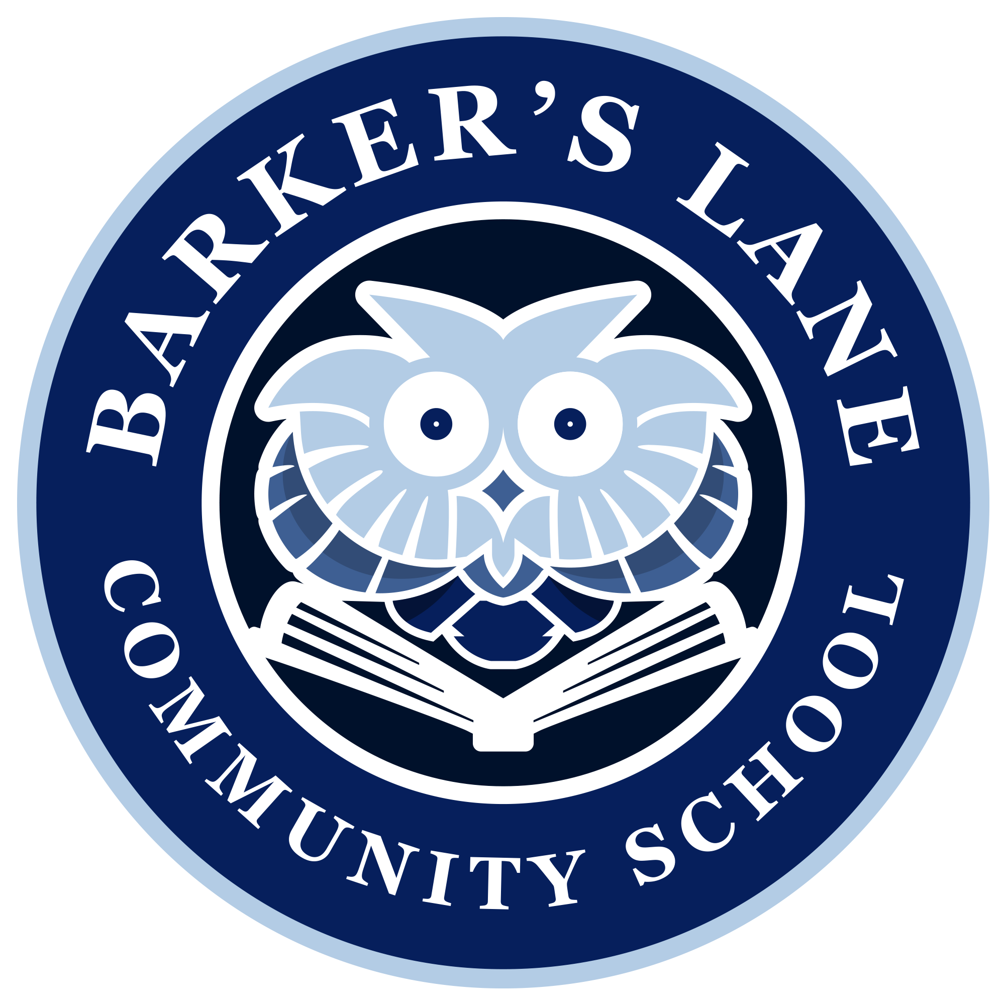

LEARN TOGETHER
‘Let’s learn to enjoy, achieve, respect and nurture together’

28th August 2020

Dear Parent / Carer

I trust that your children have been having a good break and have been able to enjoy more freedom to play outside and with friends over the Summer. Thankfully we have had some lovely weather to make the most of being outdoors, although our usual bank holiday weather seems to have reappeared this week!

I hope that your children are looking forward to coming back to school over the next few weeks. As parents / carers you may have mixed feelings about this but please be reassured we have been and will continue to be meticulous with our planning to ensure that we provide your children with the best possible safe experiences within the guidelines that we have to operate.

Welsh Government published the latest guidance for schools in the last couple of weeks which we have been and will be using to make any necessary changes to our risk assessments. We will publish any new parent and pupil information booklets by the end of the day on 2nd September.

Although I wrote to you before school closed, I thought it might be useful to clarify a few queries before we return to school:

Minimising contacts and social distancing – Our focus will be on minimising contacts and mixing between different classes, reducing the possibility of transmission between class groups. Where possible we will encourage and remind children, particularly older year groups about keeping a distance from others where they can. Staff will need to maintain a safe distance from each other and yourselves as other adults, and children will be discouraged from touching adults in an age appropriate way. WG have asked schools to strongly discourage parents / carers from congregating outside school gates – we were very successful with this before the Summer holiday, so thank you for your support with this. We will be sharing lots more information about all of this in our updated booklets next week.

School uniform – Our policy is currently relaxed. Children may wear uniform or their own clothes when they return to school. Footwear should be trainers, pumps or substantial shoes which are suitable for sporting / outdoor activity. If you would like your child to wear uniform, we ask that they wear jogging / tracksuit trousers, shorts or leggings with their polo shirt and sweatshirt / cardigan not a traditional school skirt or trousers please. We will be reviewing our policy early in the Autumn Term and will give plenty of notice if a decision is made to reinstate this after October half term.

A grant is available for items of school uniform, sports kit and equipment from Welsh Government if your child is entering Reception, Year 3, Year 7 or Year 10 if you are in receipt of certain benefits. More information is available on https://www.wrexham.gov.uk/service/pupil-development-grant-pdg

Personal belongings – These must be kept to a minimum please. Each day your child should only bring their water bottle, a shower proof coat and a lunch box / bag if they are not having school dinners. Y1-6 children will also need to bring a piece of washed / small tub of fruit or vegetables.
Unless your child is having a packed lunch, they should not bring a bag to school please.
Lunch bags / boxes for packed lunches should be as small as practically possible to just hold lunch and drinks bottles please.
If you are going to be providing a packed lunch for your child, please ensure that they can open everything independently and that they have any cutlery that they need for yoghurts etc.

Pencil case – Before the holiday we asked if Y1-6 children could bring a small pencil case with coloured pencils / felt pens which will be left in school. If you have prepared this, please send this in on your child’s first day back and they will then leave this in their tray. Diolch. Please do not worry if you have been unable to provide this, we will ensure all children in these year groups have their own stationary.

Snack – Fruit snack will be provided for Early Years children for a small charge. Details to follow next week. If your child is moving into Y1 -6, they will also need to bring a piece of washed / small tub of fruit or vegetables for their morning snack. NO CRISPS, SUGARY FRUIT SNACKS OR SUGARY CEREAL BARS PLEASE.
If you have any snack monies carried over from last year, these will be credited to your SchoolMoney account.

School meals – Hot dinners will be available when the children return to school. School dinners will need to be paid for in advance online using your child’s unique WCBC number (not using the SchoolMoney app). Please do not send cash or cheques into school. If you have any queries about school meals or credit on your account, please contact the school office by email and these will be dealt with between 1st and 3rd September. Please note, there is change to the WCBC menu as outlined below:
 | Monday | Tuesday | Wednesday | Thursday | Friday
Week 1  Commencing 1/9/2020 | Sausages & Waffles  or  Macaroni Cheese & Crusty Bread  Beans / Peas  Flapjack | Chicken Curry & Rice with Naan  or  Quorn Nuggets & Wedges  Sweetcorn  Cocoa Cookie | Beefburger Bap & Diced Potatoes  or  BBQ Quorn Pasta Bake & Crusty Bread  Peas  Cupcake | Roast Beef or Quorn Fillet served in a Yorkshire Pudding  Mashed Potatoes  Peas, Carrots & Gravy  Krispie Cake | Breaded Salmon  or  Chicago Town Pizza  Chips  Peas  Frozen Yoghurt
Week 2  Commencing 7/9/2020 | Breaded Chicken Fillet & Diced Potatoes  or  Quorn Curry & Rice with Naan  Beans / Peas  Shortbread Biscuit | Pizza  or  Country Veg Bake  Chips  Peas / Spaghetti Hoops  Muffin Medley | Pulled Pork Bap & Potato Wedges  or  Tomato & Basil Pasta with Crusty Bread  Sweetcorn  Ice Cream | Sausage or Vegetarian Sausage  served in a Yorkshire Pudding  Mashed Potatoes  Farmhouse Mix Veg & Gravy  Cornflake Cake | Fish stars  or  Quorn Nuggets  Chips  Peas / Beans  Mini Doughnuts
The menu will alternate each week until further notice e.g. Week 1 menu will be in operation on 14/9/2020

Phased return –Information was emailed before the holiday about phased return and text messages were sent with your child’s group and start date. Where possible, your child will be returning to their previous class teacher for a short time and then will transition to their new class. Full details about this were emailed before the holiday. A reminder of start dates:

New Year Group | Group A Session/s  (Half Class) | Group B Session/s  (Half Class) | Whole Class Commence Fully
Reception  (previously Nursery) | Monday 7th & Thursday 10th September | Tuesday 8th & Friday 11th September | Monday 14th September
Y1  (previously Reception) | Tuesday 8th September | Wednesday 9th September | Thursday 10th September
Y2 (previously Y1) | Tuesday 8th September | Wednesday 9th September | Thursday 10th September
Y3 (previously Y2) | Tuesday 8th September | Wednesday 9th September | Thursday 10th September
Y4 (previously Y3) | Tuesday 8th September | Wednesday 9th September | Thursday 10th September
Y5 (previously Y4) | Friday 4th September | Monday 7th September | Tuesday 8th September
Y6 (previously Y5) | Friday 4th September | Monday 7th September | Tuesday 8th September

If you are unsure whether your child is in Group A or Group B, we would appreciate if you could please check back for a text message from school between 14th – 17th July in the first instance before emailing the school office. Diolch yn fawr.

We will be sharing information about staggered start and finish times early next week. Start times will be no later that 8.55am and finish times will be no earlier than 2.55pm, similar to our usual school days. We have also worked hard to ensure siblings start and finish at the same time to reduce adult numbers on our yard / by the gates as much as possible.

Nursery 2020 – Full details of start dates and settling in sessions were shared on Seesaw just before the Summer holiday.

Wraparound Care – Holiday Club is open between 7th – 11th September for any families that require childcare before your child’s start date. Full details were shared prior to the Summer and bookings can be made with Mrs Brand on the SchoolMoney app. If you have any queries, please email RobinsonC38@hwbcymru.net
Before School, Breakfast and After-School Club will be open from 7th September although there are a reduced number of places. Please only book if this care is essential in the first few weeks until Club have assessed their capacity fully. Bookings are made in the usual way on the Club section of the SchoolMoney app.
Please be aware that your child will be mixing with children from other classes across school when attending Club. They do not have the capacity to keep contact groups separate.

Increasing capacity at our school – It seems a very long time ago now that WCBC made the decision to increase capacity for pupils at Barker’s Lane. This September the Local Authority have admitted our first larger cohort of up to 45 children creating a morning and afternoon Nursery class.
We are now anticipating that the necessary processes around planning to increase the size of the building will begin very soon. We will keep you updated with any information that we have, however, from experience, these things can often be published in the press before / at the same time as we get to know what is happening due to the nature of the process. I assure you that if / when we know about any changes, we will let you know.

If you have any specific queries / questions which relate to your individual child’s needs for their return to school, we will be available to answer them from 1st September. If possible, we ask that you wait to read the revised information booklets which will be published by the end of the day on 2nd September before emailing for general information. Diolch yn fawr.

As always thank you for all of your ongoing support and the many kind words and messages of good will that we have received. We look forward to welcoming your children and you as families back to school in September.

Enjoy the long weekend.

Warm wishes

Mrs Edwards

